PHYSICS 20
UNIT 2: DYNAMICS
Chapter 3: Forces Can Change Velocity
  - Inquiry Lab: Relating Acceleration and Net Force

Procedure
- Set up the following table into your notebook
Distance ____ (m)

Hanging  Mass  (kg) | Force  (N) | Net Force (N) | Time (s) |  |  | Average  Time (s) | Acceleration  (m/s²)
Hanging  Mass  (kg) | Force  (N) | Net Force (N) | Trial 1 | Trial 2 | Trial 3 | Average  Time (s) | Acceleration  (m/s²)

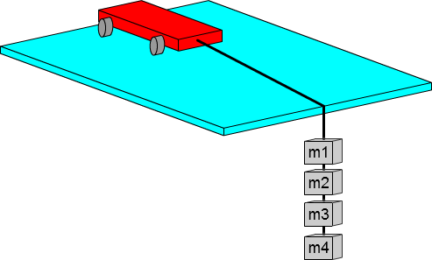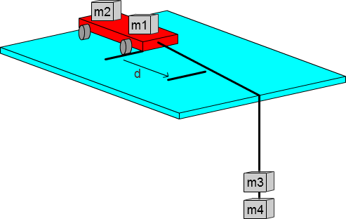
Step 3 - Initial set up
Step 7 – Move masses onto the cart from the string and repeat

- Measure and record the mass of each of the 3 masses.
- Set up the tape pieces, the masses, string and cart.
- Measure and record the distance between the pieces of tape.
- Release the cart and simultaneously start the timer, stop the timer when the cart reaches the second piece of tape, and record the time.
- Repeat several times
- Repeat steps 5 and 6 but move a mass from the cart to the end of the string.
- Move another mass onto the cart and repeat steps 5 and 6 until there are no more masses on the string.

Analysis
- Calculate the force acting on the cart. (show a sample calculation)
- Calculate the acceleration. (show a sample calculation)
- Plot the acceleration as a function of the force graph.
- What is the slope and what does it represent?
- What is the x intercept and what does it represent?
- Subtract the x intercept from each force to get the net forces and plot a graph of the magnitude of the acceleration as a function of the net force.
- What type of mathematical relationship does the graph show and how can you tell?
- When the magnitude of the net force acting on the system is doubled, what happens to the magnitude of the acceleration of the system? (Use values from your graph)
- Write the relationship between the magnitude of the acceleration and the magnitude of the net force as a proportionality statement.
- Does your experiment demonstrate Newton’s second law, and explain how you know from the graph.
- Why were the extra masses kept on the cart for the trials?
- Hidden bonus question.

PHYSICS 20
UNIT 2: DYNAMICS
Chapter 3: Forces Can Change Velocity
  - Inquiry Lab: Relating Acceleration and Net Force
Lab Repot

Marking Sheet

Background Information 0 1 2 3 4
Newton’s second law; Acceleration equation; Force applied equation; Graph x intercept

Observations 0 1 2 3 4
Tables; Labels; Units

Analysis
Force example: equation, substitution, answer 0 1 2 3
Acceleration example: equation, substitution, answer 0 1 2 3
Acceleration vs. Force graph 0 1 2 3
Slope and what it represents 0 1 2
X intercept value and what it represents 0 1 2
New force values 0 1
Acceleration vs Net Force graph 0 1 2 3
Mathematical relationship 0 1
Doubling statement 0 1 2
Proportionality statement 0 1 2
Newton’s 2nd law proof 0 1 2
Extra masses on cart 0 1 2 3 4

Evaluation 0 1 2 3
Conclusion and why
Relationship to class
Possible sources of error

Application 0 1 2
Who could use this to make money

Hidden Bonus Question 0 1 2

